BUCKINGHAM COUNTY RECREATION DEPARTMENT

YOUTH CO-ED SOCCER REGISTRATION FORM

[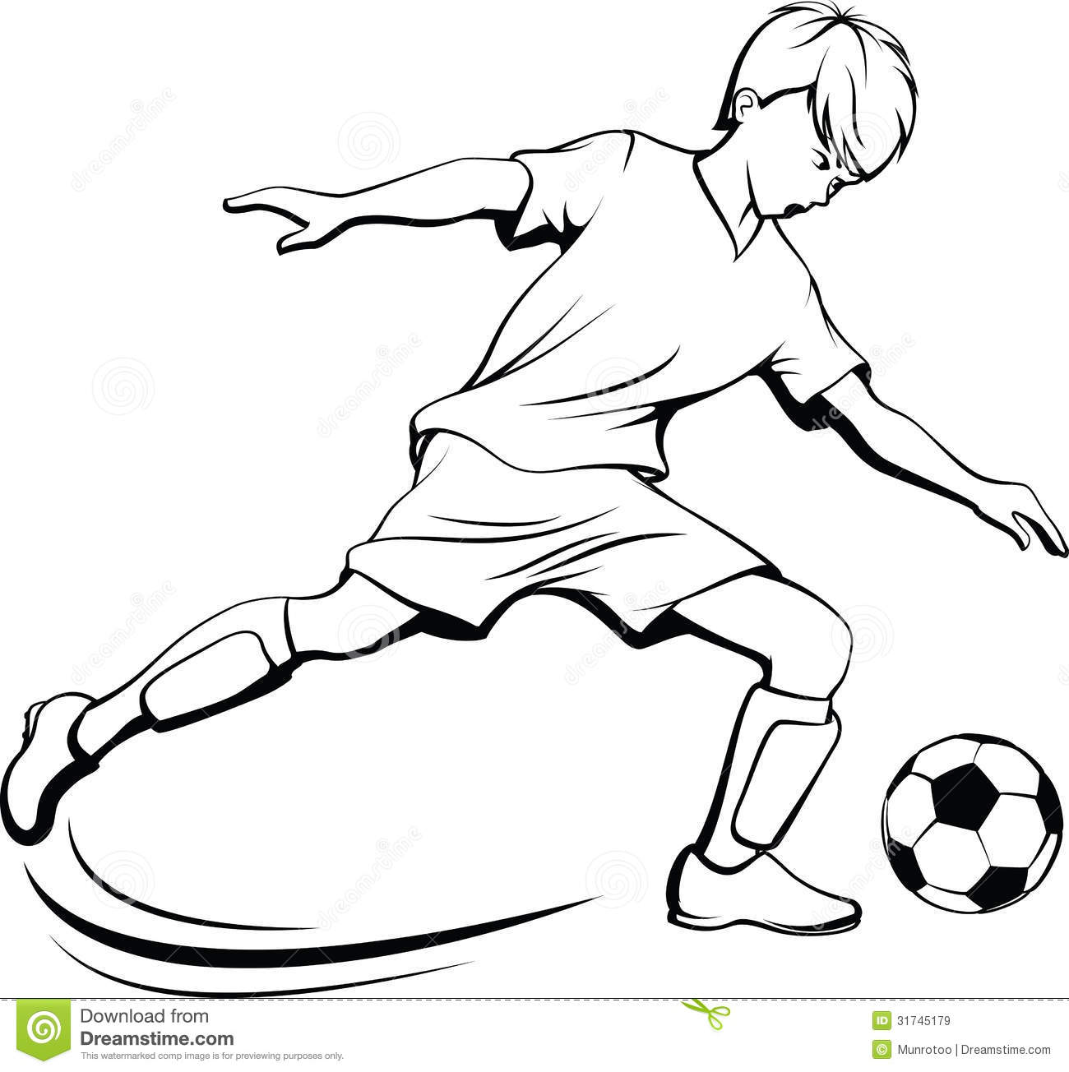](http://www.google.com/url?sa=i&rct=j&q=&esrc=s&source=images&cd=&cad=rja&uact=8&ved=0CAcQjRxqFQoTCN2ymra34MYCFcJ6Pgod5oEPIw&url=http://www.schoolclipart.biz/football-clipart-free-black-classic-black-and-white-movies-13339/football-clipart-free-black-classic-black-and-white-movies-boy-soccer-player-with-splatter-ball-royalty-free-stock-images-image/&ei=XwyoVZ2HCML1-QHmg76YAg&bvm=bv.97949915,d.cWw&psig=AFQjCNHz2V6Q8RzCPzX8KPipTojfakFGIA&ust=1437162964304016)

**Start Date:** August 23, 2021

**Practice Days**: Mondays and Wednesdays

**Time:** 5:30PM to 6:30PM

**Location:** Nazarene Camp Soccer Field

**Ages:** 4-5

**Cost:** $40.00

$45.00 if signup after September 1, 2021

**Deadline: September 1, 2021 *ALL FORMS ARE DUE BY THIS DATE!**

Childs Full Name ______________________________ Age_______ Birthday _______________

Current School child is attending __________________________________ Grade____________

Contact: Name_________________________________ Home Phone______________________

Cell Phone____________________ Cell Phone Carrier(For text messages)__________________

Emergency Contact: Name______________________________ Phone_____________________

Has your child participated in Soccer before? Yes_____ No_____ Team Last Season? _________

Address________________________________________________________________________

City _________________________________ State ______________ Zip ___________________

Email _________________________________________________________________________

__________________________________ ____________________________________

Parent/Guardian **Print** Parent/Guardian **Sign**

**T-Shirt Size: (Circle One)**

Youth Small Youth Medium Youth Large

Adult Small Adult Medium Adult Large Adult X-Large Adult XX-Large

*All fees must be paid before participation. If the fee is not paid, your child cannot participate in the Buckingham County Recreation Department Soccer Program.

**Please provide a copy of your child’s birth certificate.**

**Complete registration form and mail to Buckingham County Recreation Department,**

**P. O. Box 252 Buckingham, VA 23921**

**Please Make Checks Payable to BCRD or Pay Online at www.paygov.us**

**Any questions please call 434-969-4242 or email wspivey@buckinghamcounty.virginia.gov**

**Date:___________ Cash:____________ Check:____________ Credit Card:___________ Received By:___________**

**PARENTAL AUTHORIZATION AND MEDICAL REALEASE**

I, parent or guardian, of the child whose name is listed on the same line with my signature below, hereby give approval for his/her participation in Buckingham County Recreation Department activities. I assume all risks and hazards incidental to such participation including transportation to and from all activities; and do hereby waive, release, absolve and indemnify and agree to hold harmless the Buckingham county Recreation Department, the organizers, sponsors, supervisors, participants, and person transporting the child to and from activities, for any claim arising out of injury to the child, except to the extent of the amount covered by accident and/or liability insurance held by the local league.

I also grant permission to managing and/or coaching personnel, or other league representative or officials to authorize and obtain medical care and treatment from any licensed physician, hospital, or medical clinic including major surgery, deemed necessary by a duly licensed physician should the child become ill or injured while participation in activities away from home, or at other times when neither parent/guardian is available to grant authorization for emergency treatment.

I understand that I will be notified as soon as possible if any such accident should occur.

**\*\*\*If you have already filled out this form completely and there are no recent changes, you only have to sign the last page, but please be sure all medical information is up to date!\*\*\***

Child’s Name: __________________________________________________________

Insurance Policy Holder’s Name: ___________________________________________

Insurance Carrier: _______________________________________________________

Insurance Policy Number: _________________________________________________

**Additional Information in case you cannot be contacted:**

Please List All Allergies Your Child May Have: ___________________________________________

**Buckingham County Recreation Department**

**Release of Liability for Minor Participants**

**Read Before Signing**

IN CONSIDERATION OF__________________________________ (Name of Minor Child/Ward), my child/ward, being allowed to participate in any way in the Buckingham County Recreation Department related events and activities, the undersigned acknowledges, appreciates, and agrees that:

The risk of injury to my child from the activities involved in these programs is significant, including the potential for permanent disability and death, and while particular rules, equipment, and personal discipline may reduce this risk, the risk of serious injury does exist; and;

1. FOR MYSELF, SPOUSE, AND CHILD, I KNOWINGLY AND FREELY ASSUME ALL SUCH RISKS, both known and unknown, EVEN IF ARISING FROM THE NEGLIGENCE OF THE RELEASEES, or others, and assume full responsibility for my child’s participation; and
2. I willingly agree to comply with the programs stated and customary terms and conditions for participation. If I observe any unusual significant concern in my child’s readiness for participation and/or in the program itself, I will remove my child from the participation and bring such attention of the nearest official immediately; and
3. I, myself, my spouse, my child, and on behalf of my/our heirs, assigns, personal representatives and next of kin, HEREBY RELEASE AND HOLD HARMLESS Buckingham County Recreation Department; it’s directors, officers, officials, agents, employees, volunteers, other participants, sponsoring agencies, sponsors, advertisers, and if applicable, owners and lessors of premises used to conduct the event (“Releases”), WITH RESPECT TO ANY AND ALL INJURY, DISABILITY, DEATH or loss or damage to person or property incident to my child’s involvement or participation in these programs, WHETHER ARISING FROM THE NEGLEGENCE OF THE RELEASEES OR OTHERWISE, to the fullest extent permitted by law.
4. I, for myself, my spouse, my child, and on behalf of my/ours heirs, assigns, personal representatives and next of kin, HEREBY IDEMNIFY AND HOLD HARMLESS all the above Releasees from any and all liabilities incident to my involvement or participation in these programs, EVEN IF ARISING FROM THEIR NEGLIGENCE, to the fullest extent permitted by law.

I HAVE READ THIS RELEASE OF LIABLITY AND ASSUMPTION OF RISK AGREEMENT, FULLY UNDERSTAND ITS TERMS, UNDERSTAND THAT I HAVE GIVEN UP SUBSTANTIAL RIGHTS BY SIGNING IT, AND SIGN IT FREELY AND VOLUNTARILY WITHOUT ANY INDUCEMENT.

______________________________________

Parent/Guardian **Printed Name**

______________________________________ ________________________

Parent/Guardian **Signature**  Date Signed

**WAIVER/RELEASE FOR COMMUNICABLE DISEASES INCLUDING COVID-19**

ASSUMPTION OF RISK / WAIVER OF LIABILITY / INDEMNIFICATION AGREEMENT

In consideration of being allowed to participate in the **Buckingham Soccer Program**,

the undersigned acknowledges, appreciates, and agrees that:

1. Participation includes possible exposure to and illness from infectious diseases including but not limited to MRSA, influenza, and COVID-19. While particular rules and personal discipline may reduce this risk, the risk of serious illness and death does exist; and,
2. I KNOWINGLY AND FREELY ASSUME ALL SUCH RISKS, both known and unknown, EVEN IF ARISING FROM THE NEGLIGENCE OF THE RELEASEES or others, and assume full responsibility for my participation; and,
3. I willingly agree to comply with the stated and customary terms and conditions for participation as regards protection against infectious diseases. If, however, I observe any unusual or significant hazard during my presence or participation, I will remove myself from participation and bring such to the attention of the nearest official immediately; and,
4. I, for myself and on behalf of my heirs, assigns, personal representatives and next of kin, HEREBY RELEASE AND HOLD HARMLESS **Buckingham County Parks and Recreation Department / County of Buckingham**, their officers, officials, agents, and/or employees, other participants, sponsoring agencies, sponsors, advertisers, and if applicable, owners and lessors of premises used to conduct the event (“RELEASEES”), WITH RESPECT TO ANY AND ALL ILLNESS, DISABILITY, DEATH, or loss or damage to person or property, WHETHER ARISING FROM THE NEGLIGENCE OF RELEASEES OR OTHERWISE, to the fullest extent permitted by law.

**I HAVE READ THIS RELEASE OF LIABILITY AND ASSUMPTION OF RISK AGREEMENT, FULLY UNDERSTAND ITS TERMS, UNDERSTAND THAT I HAVE GIVEN UP SUBSTANTIAL RIGHTS BY SIGNING IT, AND SIGN IT FREELY AND VOLUNTARILY WITHOUT ANY INDUCEMENT.**

**FOR PARTICIPANTS OF MINORITY AGE (UNDER AGE 18 AT THE TIME OF REGISTRATION)**

This is to certify that I, as parent/guardian, with legal responsibility for this participant, have read and explained the provisions in this waiver/release to my child/ward including the risks of presence and participation and his/her personal responsibilities for adhering to the rules and regulations for protection against communicable diseases. Furthermore, my child/ward understands and accepts these risks and responsibilities. I for myself, my spouse, and child/ward do consent and agree to his/her release provided above for all the Releasees and myself, my spouse, and child/ward do release and agree to indemnify and hold harmless the Releasees for any and all liabilities incident to my minor child’s/ward’s presence or participation in these activities as provided above, EVEN IF ARISING FROM THEIR NEGLIGENCE, to the fullest extent provided by law.

______________________________________

Parent/Guardian **Printed Name**

____________________________________ ________________________

Parent/Guardian **Signature**  Date Signed